**Collisions: Conservation of Momentum**

Name: ____________________________________________________Period: _______ Date: ________

In all ________________, momentum is __________________. This means that the ___________ momentum has to be the same as the ______________ momentum before and after the collision.

There are two types of collisions:

1. _____________ collision 2. _____________ collision

**Inelastic** **Collision**: is a collision in which _____________ is conserved but some ___________________ is transformed into other forms of energy such as heat and sound.

***Perfectly inelastic collisions*** are those in which the colliding bodies ***stick*** ***together*** before or after impact.

If we apply conservation of momentum, we start defining that the momentum before the collision is the same as the momentum after the collision for the entire system.

**pbefore=pafter**

**m1v 1+ m2v2 = (m1 + m2)vf**

**or**

**(m1 + m2)vi =m1v 1+ m2v2**

**Elastic Collision**: is one in which both the _____________________and ____________ of the system are conserved. No kinetic energy is lost as

heat, sound, or other energy forms.

After an elastic collision, each mass continues ***independently*** with its own momentum.

If we apply conservation of momentum, we start defining that the momentum before the collision is the same as the momentum after the collision for the entire system.

**pbefore=pafter**

**m1v 1+ m2v2 = m1v1’ + m2v2’**

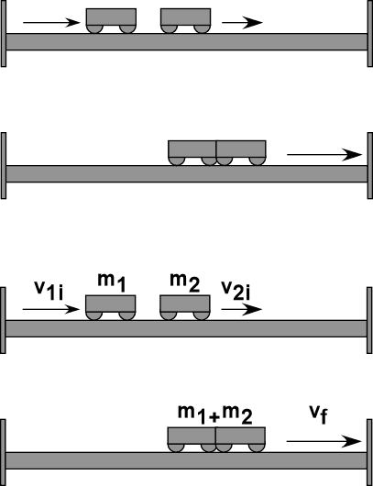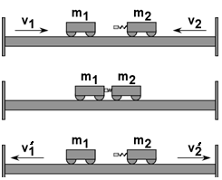

Ex1. A car of mass 1000 kg travelling west at 20 m/s crashes into the rear of a stationary bus of mass 5000 kg. The vehicles ***lock******together*** on impact. Assume that road friction is negligible.

**a.** What is their joint velocity immediately after the collision?

**b.** What is the total kinetic energy of the system before the collision?

**c.** What is the total kinetic energy of the system after the collision?

**d.** Is this an elastic or inelastic collision? Explain.

Ex2. A 100 g ball traveling to the right at 2 m/s strikes a 200 g ball traveling to the left at 4 m/s. After the collision, the 100 g ball has a velocity of 8 m/s to the left. What is the velocity of the 200 g ball?

Ex3. A 925 kg car moving at a velocity of 18.0 m/s right collides with a stationary truck of unknown mass. The two vehicles ***lock together*** and move off at a velocity of 6.50 m/s. What is the mass of the truck?

Ex4. An archer stands at rest on frictionless ice and fires a 0.500kg arrow horizontally at 50m/s. The combined mass of the archer and bow is 60kg. With what velocity does the archer move across the ice after firing the arrow?

