**LAWS OF MOTION: FRICTION I**

Name: _______________________________________________Period: ______ Date: ________

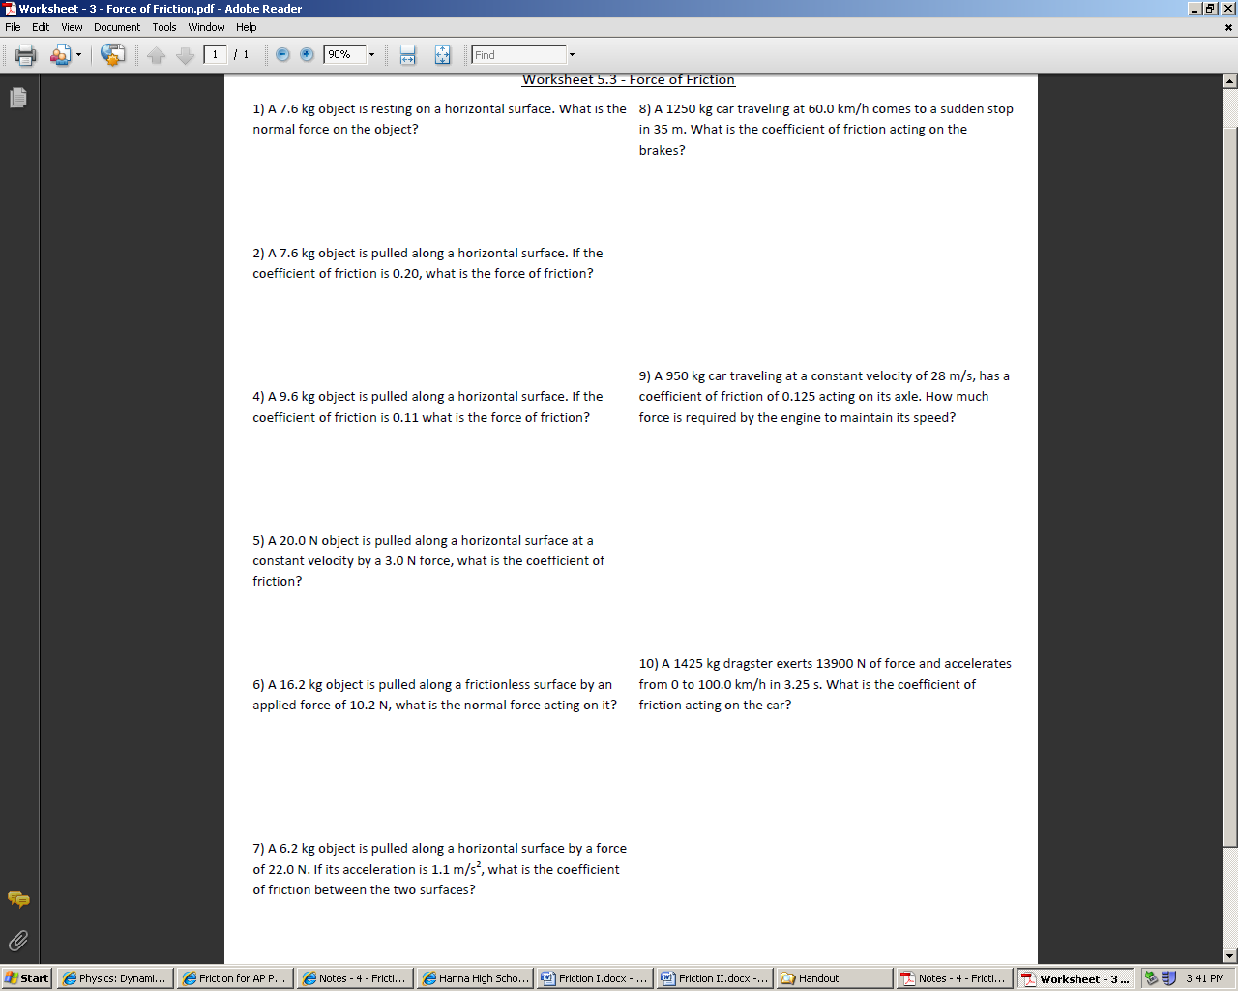**I. Solve the following problems**

**ANSWERS**

1.____________

2.____________

3.____________

4.____________

5.____________

6.____________

7.____________

8.____________

9.____________

