LAWS OF MOTION: TENSION PROBLEMS I
Name: _______________________________________________Period: ______ Date: ________

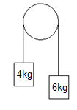
1. Two blocks, m₁= 6kg and m₂= 4 kg blocks are hanging from a frictionless pulley and released at rest. Find:
a. The acceleration of the system. _____________
b. The tension in the string. _____________

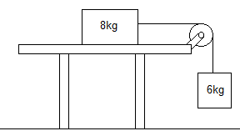
2. A mass on a frictionless table is attached to a hanging mass over a frictionless pulley as shown. Find:
a. the acceleration of the masses _____________
b. the tension in the rope _____________

3. If the 8kg block from the system from problem 2 has a friction force of 25N acting on the 8kg, find:
a. the acceleration of the masses _____________
b. tension in the rope _____________

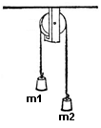
4. Two blocks (m1 = 7.0 kg and m2 = 13.0 kg) are connected by a rope over a pulley as shown.
a) What is the acceleration of m1? _____________
b) What is the acceleration of m2? _____________
c) What is the tension in the rope on m1? _____________
d) What is the tension in the rope on m2? _____________
e) The distance each objet will move in the first two seconds of motion if both objects start from rest. _____________

5. Two masses (m₁ = 20.0 kg and m₂ = 10.0 kg) are attached by a string as shown:
a) Determine the acceleration of m2 assuming that the table
m2
is frictionless. _____________
b) Find the tension in the rope (no friction). _____________
m1
c) Determine the acceleration there is a force of friction of 40N.
d) Find the tension on the rope (yes, now with friction). _____________

3. Three masses are attached (m1 = 19.0 kg, m2 = 11.0 kg, m3 = 5.0 kg) as shown.
Assuming no friction for, determine:
m1
m2
- What is the acceleration of the blocks?
_____________
- What is the tension in the string at point A?
m1
_____________

c) What is the tension in the string at point B? _____________

4. Look at the diagram from question 3. If the force of friction on m2 is 35 N and the force of friction on m3 is 18 N, find their acceleration. ____________________

