Combined Electric Circuits Quiz
Name: ______________________________________________________ Period: _________ Date: __________
I. Simplify the following electric circuits. Show your work to get full credit.
SERIES | PARALLEL | Formulas
V=V₁+V₂+V₃+… | V=V₁ =V₂=V₃=… | V=IR
I=I₁=I₂=I₃=... | I=I₁ + I₂+ I₃+… | P=IV=I²R
R=R₁+R₂+R₃+… | $\frac{1}{R_{T}}=\frac{1}{R_{1}}+\frac{1}{R_{2}}+\frac{1}{R_{3}}$+… | E=Pt

1.
SIMPLIFY & DRAW THE CIRCUIT STEP BY STEP.
1.

2.

3.

4.

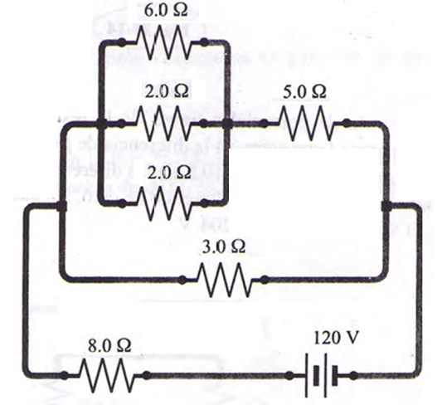
a. Total Resistance in the circuit: ________________
b. Current flowing in the circuit: ________________
c. Voltage on the 8Ω resistor: _________________
d. Voltage on the 3Ω resistor: _________________
e. Voltage on the 6Ω resistor: _________________
f. Current on the 6Ω resistor: _________________
g. Current on the 3Ω resistor: _________________
h. Current on the 5Ω resistor: _________________

