Name: Period: Date:

Electricity: Capacitors Problems 2

SERIES | PARALLEL
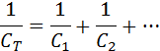
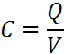 | 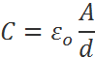 | 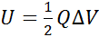=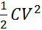

I. Simplify the following electric circuits and answer the following.

1. 2.

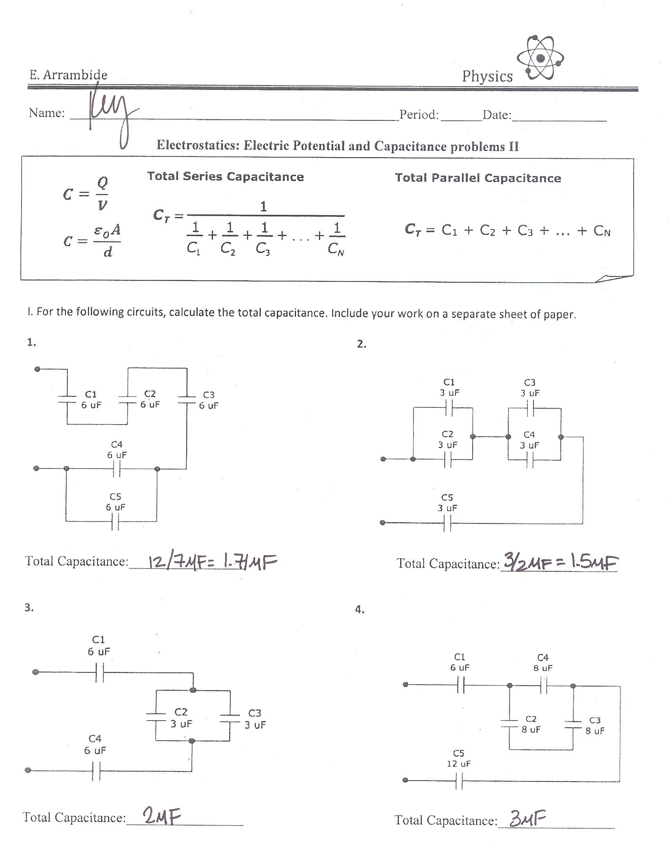

Type of circuit: _______________________ Type of circuit: _______________________

Total Capacitance: _____________________ Total Capacitance: _____________________

3. 4.

Type of circuit: _______________________ Type of circuit: _______________________

Total Capacitance: _____________________ Total Capacitance: _____________________

5. 6.

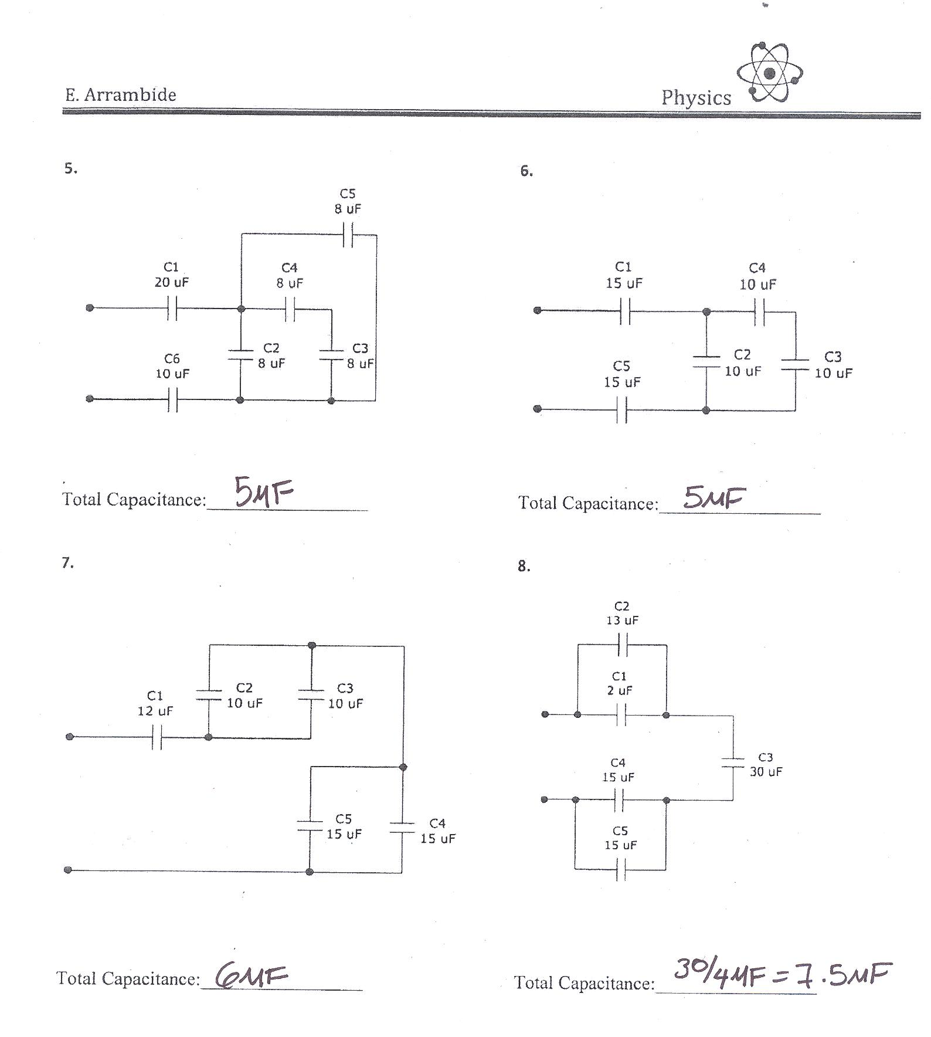

Type of circuit: _______________________ Type of circuit: _______________________

Total Capacitance: _____________________ Total Capacitance: _____________________

7. 8.

Type of circuit: _______________________ Type of circuit: _______________________

Total Capacitance: _____________________ Total Capacitance: _____________________

II. Answer the following. Show all your work

1. A 8 nanofarad parallel plate capacitor holds a charge of magnitude 45µC on each plate.
a. What is the potential difference between the plates?
b. If the plates are separated by a distance of 0.2mm, what is the area of the plate?
c. What the electric potential energy stored in the capacitor?

2. Capacitor C1 consists of square parallel plates 10cm on a side, and separated by a distance of 4mm, as shown. Capacitor C2 has squared parallel plates 5cm on a side, and separated by a distance of 1mm.
a. What is the capacitance of the first capacitor? _______________________
b. What is the capacitance of the second capacitor _______________________
c. What is the ratio between the capacitances of the two parallel-plate systems? [C₁:C₂]_______________

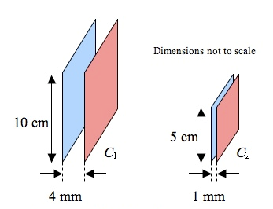

3. A capacitor is fully charged by a 10V battery and has 20miliJoules of energy stored in it..
a. Find the charge on each conducting plate of the capacitor. ___________________
b. Find the value of the capacitance. ___________________
c. Find the separation of the plates is the surface area is 2.5mm² ___________________

