Kinematics with Graphs
Name: ______________________________________________________Date: ____________Period: _________
SUMMARY

The slope of this segment gives the average velocity between a and b.
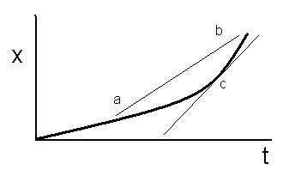
FACTS TO REMEMBER
The slope of a position vs. time graph gives VELOCITY.
The slope of a velocity vs. time graph gives ACCELERATION.
The area under a velocity vs. time graph gives DISPLACEMENT.
The area under an acceleration vs. time graph gives VELOCITY.

SLOPE= $\frac{Δy}{Δx}$=$\frac{y_{2}-y_{1}}{x_{2}-x_{1}}$

The slope of this tangent gives the instantaneous velocity at point c.

The slope of this segment gives average acceleration.
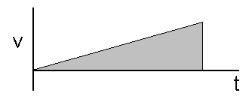
This area represents the displacement

This area represents the change in velocity.

- Use figure 1 (on the right) to calculate the following:
  - What is the average velocity from 0 to 10 seconds?
  - What is the average velocity from 10 to 20 seconds?
  - What is the average velocity from 0 to 20 seconds?
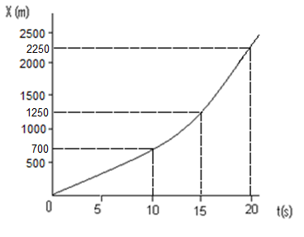
  - What is the instantaneous speed at 15 seconds?

- ________________
- ________________
- ________________
- ________________

- The velocity of a baseball player running towards a ball is shown in the following figure.
  - Find instantaneous acceleration at 3 seconds
  - Find instantaneous acceleration at 6 seconds
  - Find instantaneous acceleration at 9 seconds
  - Find the displacement for the first 4 seconds
  - Find the displacement for the first 10 seconds.
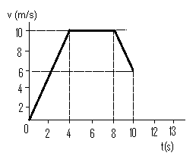
  - What was the displacement between 8-10 seconds?

- ________________
- ________________
- ________________
- ________________
- ________________
- ________________

- Use the following figure to answer the following questions.
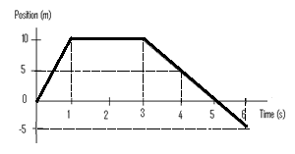
  - Find the average velocity from 0 to 1 second
- ________________
- ________________
- ________________
- ________________
  - Find the instantaneous velocity at 2 seconds
  - Find the instantaneous velocity at 5 seconds
  - Find the acceleration at 4 seconds

- Use the following figure to calculate the following.
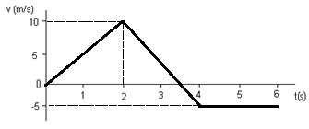
  - What is the velocity at 0s?
  - Find the acceleration for the first 2 seconds
  - What is the acceleration from t=2s to t=3.5s?
- _______________
- ________________
- ________________
- ________________
- ________________
- ________________
  - What is the acceleration from t=3.5s to t=6s?
  - How far did the object travel from t=4s to t=6s?
  - How far did the object travel from t=0s to t=3s?

