Laws of Motion: Tension (Static) Problems II
Name: _______________________________________________Period: ______ Date: ________
- Answer the following. Show all your work to get full credit.
- In the figure, if the tension in string 1 is 34 N and the tension in string 2 is 24 N, what is the mass of the object shown? ____________________

- If α = 40° and the tension in string 2 is 30 N, determine M. ____________________

- A 50-g mass is hung by string as shown in the picture above. The left-hand string is horizontal; the angled string measures 30° to the horizontal. What is the tension in the angled string?
____________________
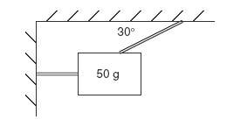

4. The two cables are used to suspend a 105 Kg object below the ceiling. Find the tension in each cable. ____________________
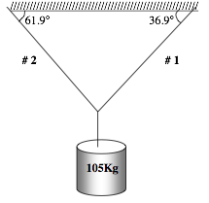
5. A 25.0-Newton sign hangs from two chains as shown below. Determine the tension in each of the chains. T_{A} = ____ T_{B} = ____
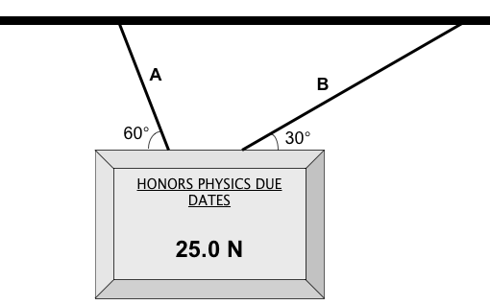

6. A 30N block is hung from 2 cords as shown in the following figure. A 20N block hangs underneath the 30N block. The lengths of the top cords are given. Determine the tensions in all 3 cords.
T1= _________ T2= __________ T3 =__________
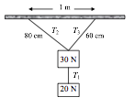
7. Consider a 10kg block resting on a frictionless plane inclined 30 º connected by a rope through a pulley to a 10kg block hanging free, as seen in the figure below. What is the direction and magnitude of the resulting acceleration of the 2-block system? _________________

