Conservation of Energy Quiz
Name: ______________________________________________________Date: ____________Period: _________
I. Answer the following. Include all your work to get full credit.
1. A 0.90 kg soccer ball is booted straight up in the air. If it left the soccer player’s foot at a height of 0.80 m and reaches a maximum height of 37.0 m,

a. what was the ball’s velocity immediately after it was kicked? ___________________

b. What was the speed of the ball when it had reached a height of 30m? ___________________

2. Frank, a San Francisco hot dog vendor, sells hot dogs at the top of Nob Hill (Point A), which is 50 m above sea level. Frank has fallen asleep on the job. When an earthquake strikes, his 300 kg hot dog cart rolls down Nob Hill and reaches the bottom of the hill (Point B, at sea level) and continues up the next hill which is 30 m above sea level (Point C).
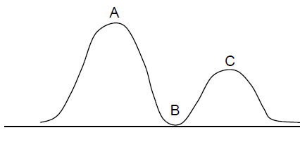
a. What is the Potential Energy at point A? __________ b. What is the Kinetic Energy at point A? ___________
c. What is the Potential Energy at point B? __________ d. What is the Kinetic Energy at point B? ___________

e. How fast is the cart moving as it passes Point B? ___________

f. How fast is the cart moving as it passes Point C? ___________

3. It is said that Galileo dropped objects off the Leaning Tower of Pisa to determine whether heavy or light objects fall faster. If Galileo had dropped a 5 kg cannonball to the ground from a height of 12 m, how fast is the object moving just before it touches the ground? ___________
A

B

