NAME: ______________________________________Date: ____________Period: _________
Unit conversion with Exponents/Geometry Review
Given: 1.00 in = 2.54 cm 12.0 in = 1.00 ft 1000 m = 1.00 km
100 cm = 1.00 m 5280 ft =1.00 mile 1.00 mile = 1.60 km
10 mm = 1.00 cm 60.0 sec = 1.00 min 60.0 min = 1.00 H
1mL=1cm³ 1Yd=3ft
Example1: 5cm² to m²

Example 2: 45ft/hr² to m/s²

I. Convert the following units. Show all your work. If necessary, show your answer in scientific notation format.
1. 3mi³ to m³ 4. 5$\frac{km}{\min^{2}}to \frac{m}{s^{2}}$

2. 850 ft² to m² 5. 12$\frac{in}{\min^{2}}to \frac{m}{s^{2}}$

3. 12yd³ to ft³ 6. 8$\frac{yd}{{hr}^{2}}to \frac{ft}{s^{2}}$

GEOMETRY REVIEW
II. Calculate the area of the following shapes. It may be necessary to break up the figure into common shapes.
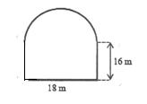
1. 2.
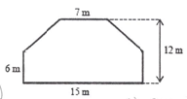
Area= ________________ Area= _______________

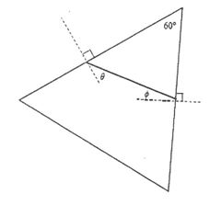
III. Calculate the unknown angle values for questions1-6
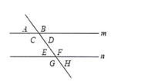

Lines m and n are parallel
A= 75° B= ___ C= _____ D= ______
Ɵ=16° E= ____ F= ___ G= _____ H= _____
Ǿ= _____
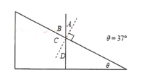
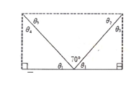

Ɵ₁=___ Ɵ₂=___ Ɵ₃=___ A= ____ B= _____
Ɵ₄=___ Ɵ₅=___ C= ____ D= _____
