LAWS OF MOTION: FRICTION II
Name: _______________________________________________Period: ______ Date: ________
I. Answer the following. Show all your work to get full credit. Use a=g=±10m/s².
1. A m₁=10kg block rests initially on a table. The coefficient of sliding friction between the block and the table is 0.3. If a second block of mass m₂= 5kg is connected on the other side of the cable,
a. Find the acceleration of the system a= _______________
b. Find the tension in the cable T= _______________
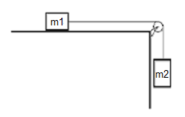

2. A floor buffer consists of a heavy base (m=15kg) attached to a very light handle. A worker pushes the buffer by exerting a force P directly down the length of the handle. If the coefficient of friction between the buffer and the floor is $µ=0.36$,
a. Draw the Free Body Diagram

b. What is the magnitude of the force P needed to keep the buffer moving at a constant velocity? (Hint: Substitution) P=___________
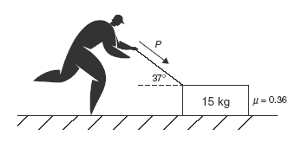

3. Three blocks are part of a system as shown. The blocks are connected by two cables, cable 1 & 2. The coefficient of friction is 0.20. Use the following information:
m₁=12kg m₂=5kg m₃=6kg Ɵ=30°
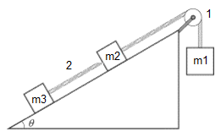
a. Draw a Free Body Diagram for each block.
m₁ m₂ m₃

b. Find the acceleration of the system. a= __________________

c. Find the values for tension 1 and tension 2.
T₁= _____________
T₂= _____________

4. A 17,340kg bus moving at a velocity of 55km/h comes to a sudden stop in 50m. What is the coefficient of friction acting on the brakes? µ=________________

