LAWS OF MOTION: FRICTION III
Name: _______________________________________________Period: ______ Date: ________
I. Answer the following. Show all your work to get full credit. Use a=g=±10m/s².
1. A 1.0 kg mass on a 37° incline is connected to a 3.0 kg mass on a horizontal surface (see figure below). The surface has a coefficient of friction of µ=0.2. If F = 20N,
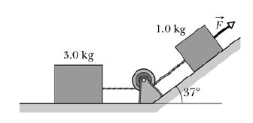
a. Draw FBD for both blocks

3kg block 1kg block

b. What is the friction for each block? fr_{3kg}=_____________ fr_{1kg}=_____________

c. what is the acceleration of the system? a= ___________________

d. what is the tension in the connecting cord? T= ___________________

2. A child pulls a 15 kg sled containing a 5.0 kg dog along a straight path on a horizontal surface. He exerts a given force F on the sled at an angle of 20° above the horizontal, as shown in the figure below. The coefficient of friction between the sled and the surface is 0.25.
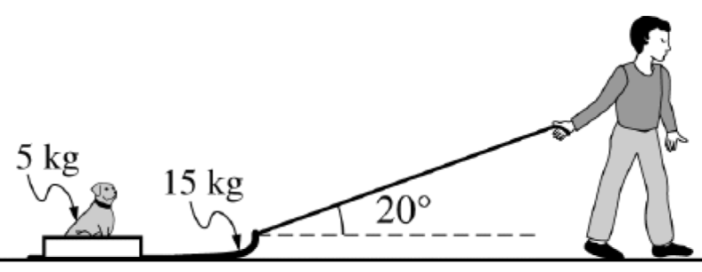
a. On the dot below that represents the sled-dog system, draw and label a free-body diagram for the system as it is pulled along the surface.

b. Calculate the applied force if the sled moves at a constant speed. F=____________________

