Laws of Motion: Incline Plane with frictionless surface
Name: _______________________________________________Period: ______ Date: ________
- Answer the following. Show all your work to get full credit.
1. Suppose you place a 10 kg box on a frictionless 30º inclined plane and release your hold, allowing the box to slide to the ground, a horizontal distance of d meters and a vertical distance of h meters.
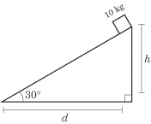
a. Draw a free body diagram for the box.

- What is the magnitude of the normal force? ______________
- What is the acceleration of the box? ______________
- What is the velocity of the box when it is released from rest and reaches the bottom of the slope if the distance covered is 35m? ______________

2. The box on the frictionless ramp is held at rest by the tension force. The mass of the box is 20 kg.
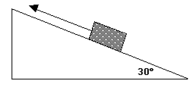

- Draw a free body diagram representing all the forces for the mass and determine the value of the tension force. T= ______________

- What is the value of the normal force? F_{n}=______________

3. In the system below the pulley and ramp are frictionless and the block is in static equilibrium. First draw a force diagram for the block on the ramp and then determine its mass.
m=______________
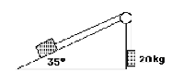

4. Rose is sledding down an ice-covered hill inclined at an angle of 15 degrees with the horizontal. If Rose and the sled have a combined mass of 54 kg, what is the force pulling them down? (Ignore frictional effects here.) F= ______________

5. Two blocks are connected by a string as shown. Both blocks are released from rest on a frictionless incline plane. Assume mass M > mass m

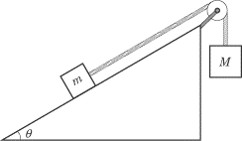
- Draw a free body diagram for block m and block M.

- Find an algebraic expression to find the acceleration of the system.

- If the angle is 25 degrees, M=50kg and m=20kg, find the acceleration of the system.
a=______________

- What is the normal force on block m. F_{n}= ______________

