Kinematics: Motion with Graphs Quiz
Name: _______________________________________________ Period: __________ Date: _________
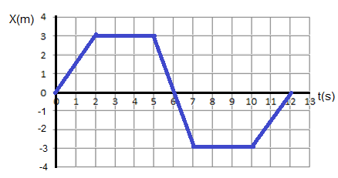
I. Use the following graphs to solve for the following. Show your work

Find the following:

- Average velocity between 0-5s __________
- Average velocity between 2-6s __________
- Instantaneous velocity at the 1s mark _________
- Instantaneous velocity at the 4s mark _________
- Acceleration at the 11s mark _________
- Total displacement for the first 6 seconds _______
- Total distance (12s) __________
- Total displacement (12s) _____________

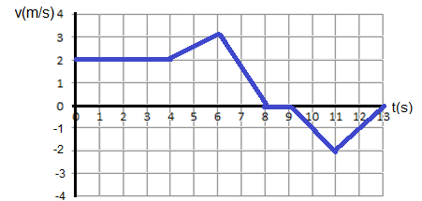

- Instantaneous acceleration at the 2 sec mark ________________
- Average acceleration between 4-8s _______________
- Final displacement ______________
- Total distance covered _______________

II. For the following graphs, describe the motion of a given object. Include:
a. If the object is at REST, moving away (+v) or moving back (-v)
b. If the object is moving [+v or –v], specify if the object is:
1. Moving at a constant velocity [CV]
2. Accelerating [+a]
3. Decelerating [-a]
A
B
C
D
E
F
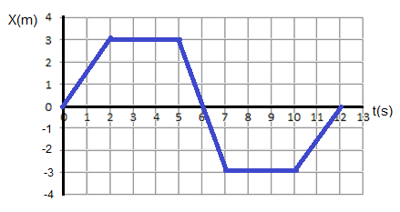

A-B __________________________________
B-C __________________________________
C-D__________________________________
D-E___________________________________
E-F ___________________________________

A
B
C
D
E
F
G

A-B _______________________________ B-C _______________________________
C-D_______________________________ D-E_______________________________
E-F _______________________________ F-G_______________________________

