Centripetal acceleration & Force problems 2
Name: ______________________________________________________Date: ____________Period: _________
$a_{c}=\frac{v^{2}}{r}=\frac{4π^{2}r}{T^{2}}$ $F_{C}=ma_{c}$ $v=\frac{d}{t}=\frac{2πr}{T}$
UNITS
m, kg, s
1. An airplane is moving on a circular path of radius 2.5 km. If it completes 3 complete cycles in 3.20min, calculate:
a. centripetal acceleration in m/s². ___________________
b. centripetal force [airplane’s mass=12,500lbs] [1kg=2.2lb] ___________________

2. Calculate the centripetal force acting on a 925 kg car as it takes a curve with a radius of 7500 cm at a speed of 79.2km/h. ___________________

3. A small plane makes a complete circle with a radius of 3.28 km in 2.0min.
a. What is the centripetal acceleration of the plane? ___________________
b. If the plane’s mass is 12,500lb, what is the centripetal force applied to the airplane? ___________________

4. A car with a mass of 833 kg rounds an unbanked curve in the road at a speed of 100.8km/h. If the radius of the curve is .105 km, what is the average centripetal force exerted on the car? ___________________

5. An amusement park ride has a radius of 2.8 m. If the time of one revolution of a rider is 0.98 s, what is the speed of the rider? ___________________

6. An electron (m=9.11x10⁻³¹ kg) moves in a circle whose radius is 2.00 x10⁻²⁰ m. If the force acting on the electron is 4.60x10⁻¹⁴ N, what is its speed? ___________________

II. Answer the following multiple choice questions.
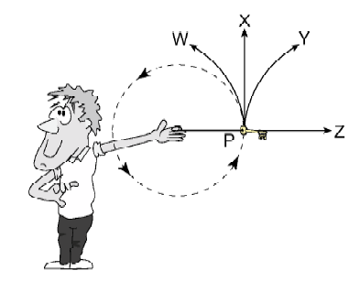
1. The diagram shows a student “twirling” a car key in a circular path on the end of a string.
If the string snaps at P, which path will the keys follow?
a. W
b. X
c. Y
d. Z

2. An athlete runs at a constant speed, around a circle of radius 5.0m in 12s. What are the athlete’s speed and acceleration?
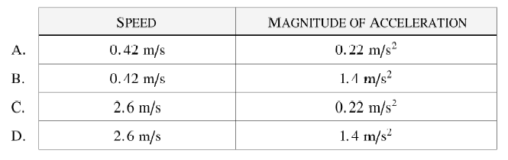
3. Which vector diagram best represents the acceleration, a, and force F for an abject traveling along a circular path?
