Kinematics with Graphs III
Name: ______________________________________________________Date: ____________Period: _________
- Read the description and draw the following x-t and v-t graphs.

- Either the following two graphs represents something that is not moving
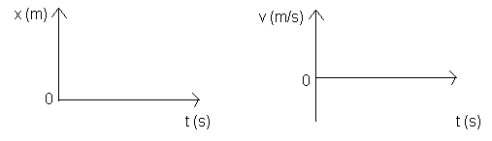
- Either of the following two graphs represents an object moving at a constant velocity in the positive direction.
- Either of the following two graphs represents an object moving at a constant velocity in the negative direction.
- Either of the following two graphs represents an object speeding up in the positive direction.
- Either of the following two graphs represents an object slowing down in the positive direction.

- Either of the following two graphs represents an object slowing down in the negative direction.
- Either of the following two graphs represents an object speeding up in the negative direction.

- For the following x-t graphs, draw the v-t graph that corresponds to it.

- 2.
