Transforming Graphs of Motion 2
Name: _____________________________________________ Date: ________________________ Period: ___________
- The middle graph shows the velocity of a hypothetical object moving along a straight line.
- Describe the motion for each section [Rest, +v,-v; CV, +a, -a]
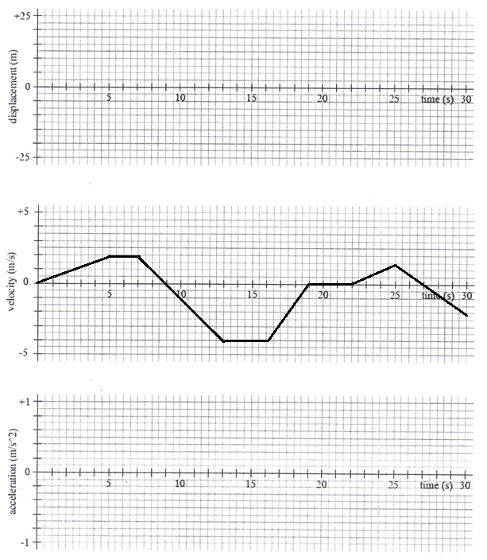
- Plot the corresponding graphs of displacement and acceleration as functions of time.
t X

II. Answer the following questions based on your graphs.
1. What is the total displacement of the object during the first 20 seconds? ________________
2. What is the total distance traveled by the object during the first 20 seconds? ________________

III. Answer the following questions by using the following X-t graph. Show your work!
- What is the average velocity from 0 to 8 seconds? _______________
- What is the instantaneous acceleration at 12 seconds? _______________
- What is the instantaneous velocity at 6 seconds? _______________
- What is the instantaneous velocity at 12 seconds? _______________

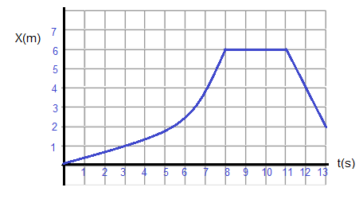

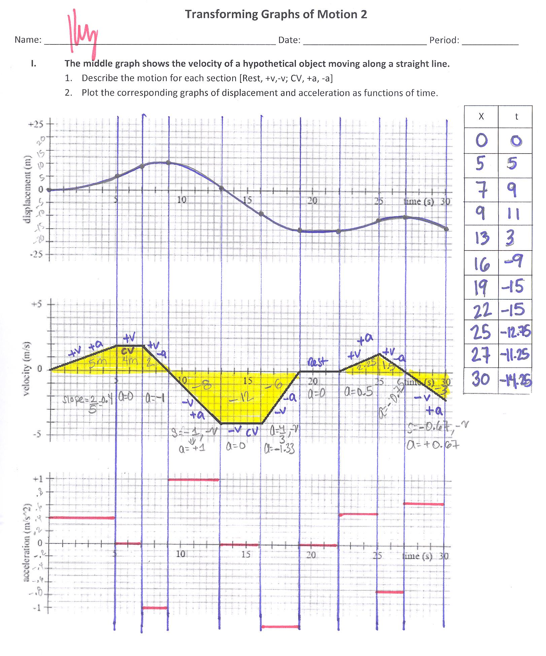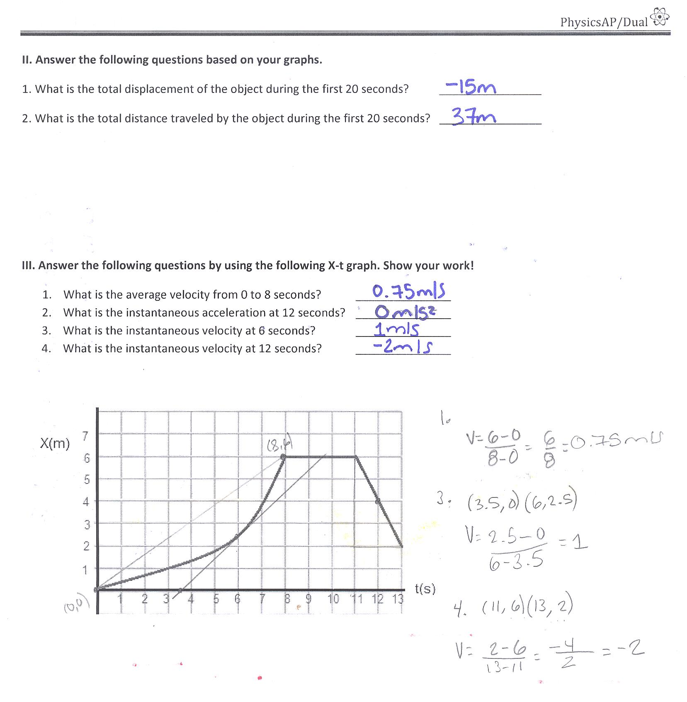
X
t

