Name: Period: Date:
Electrostatics: Electric charges and Coulomb’s Law Quiz

I. Answer the following problems. Show all the work to get full credit.
1. Two point charges produce a force between on each other of 4.5x10⁻³ N. What is the force between them if one charge triples and the distance between them triples? _________________

2. Three point charges (q₁=-3µC, q₂=5nC and q₃=-6µC) are placed at the corner of a right angle triangle as shown. Calculate the magnitude of the net electric force on q₁ due to the other two charges. ______________
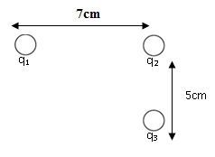

3. Two very small spheres are initially neutral and separated by a distance of 0.75m. Suppose that 3 x10¹¹ electrons are removed from one sphere and placed on the other.
a. What is the magnitude of the electrostatic force that acts on each sphere? ________________

