Name: _______________________________________________Date: ______________ Period: ______
TEST 1: Laws of Motion
I. Answer the following problems. Include all the work to receive full credit. Use a=g=±10m/s².

1. Two blocks are suspended as it is shown in the figure below. Find the tension of all 4 cables. (Cables 1 and 2 are perpendicular)

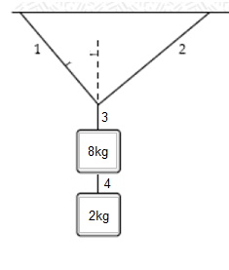
42°

T₁=______________
T₂=______________
T₃=______________
T₄=______________

2. Three blocks are part of a system as shown. The blocks are connected by two cables, cable 1 & 2. Use the following information:
m₁=5kg m₂=3kg m₃=4kg Ɵ=25°
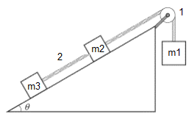
a. Draw a Free Body Diagram for each block.
m₁ m₂ m₃

b. Find the acceleration of the system.

a= __________________

c. Find the values for tension 1 and tension 2.

T₁= _____________
T₂= _____________

II. Select the correct answer.
1. When a certain force is applied to an object with a mass of 2 kg, its acceleration is 10.0 m/s². When the same force is applied to a different object, its acceleration is 4.0 m/s². The mass of second object is _____________
a. 10kg
b. 8 kg
c. 5 kg
d. 2.5 kg
e. 1.25 kg

2. A block is pushed across a horizontal surface by the force F with constant velocity. F = 20 N, θ = 30°, and M = 10kg. What is the magnitude of the normal force on the block? _____________
a. 20N
b. 88N
c. 94N
d. 100N
e. 110N

3. When an object is in equilibrium, what kind of motion can it have? _____________
a. constant acceleration.
b. constant motion.
c. constant velocity only.
d. no motion only.
e. Either C or D are correct.

Use the following for questions 4-6
An object of mass m is at rest on an inclined plane as shown below. The inclined plane forms an angle θ with the horizontal. The object slides down the ramp due to the effect of gravity. _____________

4. Which of the following diagrams correctly shows the forces acting on the object? _____________

5. The normal force acting on the object is: _____________
a. mg
b.mgcosƟ
c.mgsinƟ
d. there is no normal force

6. The force making the object slide is: _____________
a. mg
b.mgcosƟ
c.mgsinƟ
d. there is no force at all.

